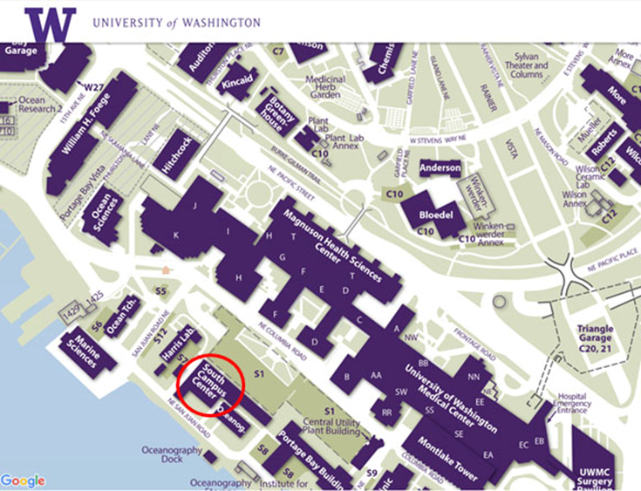

T3 Seattle Program Location August 14-17, 2017:

University of Washington Campus
South Campus Center, Room 316
1601 NE Columbia Road
Seattle, WA 98195

